I download the git bash while downloading i face one problem

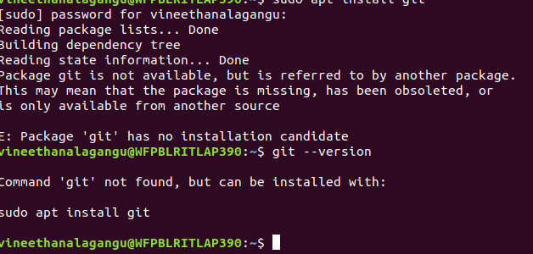
and after i overcome that by using ‘sudo apt update’.
After that by using ‘sudo apt-get install git -y’ install the git bash
And then i create the git hub account for to create git hub account i follow google.

And then i practice the linux commands:
mkdir- this is used to create the directory
syn: mkdir directoryname

mkdir release

touch-it is used to create the files
syn: touch filename

touch file1 file2
we can create any number of files at once

ls-list of files
syn: ls

date- it display the date
syn: date

cal- it display the calendar
syn:cal

cd-chance the directory
syn: cd filename

cat-it display the content in the file
and to create the file and then enter the text in that file
syn: cat filename------> this is for to display the test
cat>file------->this is for to create the file and enter the text on it

vi-it is the editor we can enter the text in the file by using this editor
syn:vi filename

once we can enter the editor press ‘i’ this means the editor enter into the insert mode after entering the text, press Esc and then ‘:wq’
u come out of the editor

who- it display the user details

man- display online manual pages

wc- it display the word count

cp-copy the text from one file to another file

rm- remove the file

rm -r filename - remove the directories with force(means any directory having the data inside at that time use this command)

chmod-- it is used to change the permissions

chgrp-- it is used to change the permissions for group

mv –it is used for to move or rename

grep – it is used to search the particular word with starting letter

